LO 1 Apply keyboard skills
1.1 Use of keyboard characters
1.1.1 Definition
A keyboard is one of the primary input devices used with a computer. A keyboard is composed of buttons used to create letters, numbers, and symbols, and perform additional functions.
1.1.2 Types
The most used keyboard layouts are QWERTY and AZERTY.
1.1.3 Parts
The main parts of keyboard are:

1.Typing (alphanumeric) keys
These keys include the same letter, number, punctuation, and symbol keys found on a traditional typewriter.

2.Control keys
These keys are used alone or in combination with other keys to perform certain actions. The most frequently used control keys are Ctrl, Alt, the Windows logo key﻿ , and Esc.

3.Function keys
The function keys are used to perform specific tasks. They are labeled as F1, F2, F3, and so on, up to F12. The functionality of these keys differs from program to program.

4.Navigation keys
These keys are used for moving around in documents or webpages and editing text. They include the arrow keys, Home, End, Page Up, Page Down, Delete, and Insert.
5.Numeric keypad.
The numeric keypad is handy for entering numbers quickly. The keys are grouped together in a block like a conventional calculator or adding machine.
a
1.2 Combination keys and their use

Description of keyboard combination keys:
Ctrl + A: Select all contents of the page.
Ctrl + S: Save the work
Ctrl + C: Copy selected text.
Ctrl + X: Cut selected text.
Ctrl + N: Open new/blank document.
Ctrl + O: Open options.
Ctrl +: P Open the print window
Ctrl + F: Open find box.
Ctrl + V: Paste.
Ctrl + Y: Redo the last action performed.
Ctrl + Z: Undo last action.
Ctrl + W: Close a window
Ctrl + G: Find option.
Ctrl + H: Find and replace options.
Ctrl + D: Duplication a single line
Ctrl + ←: Move one word to the left.
Ctrl + →: Move one word to the right.
Ctrl + ↑: Move to beginning of the line or paragraph.
Ctrl + ↓: Move to the end of the paragraph.
Ctrl + Del: Delete word to right of cursor.
Ctrl + End: Move cursor to end of document.
Ctrl + Home: Move cursor to beginning of document.

1.3 Application of typing technique

1.3.1 Typing tips

1.Hand positioning

Your left-hand fingers should be placed over the A, S, D, and F keys, and the right-hand fingers should be placed over the J, K, L, and; keys. These keys are considered the home row keys. Your thumbs should either be in the air or very lightly touching the spacebar key.

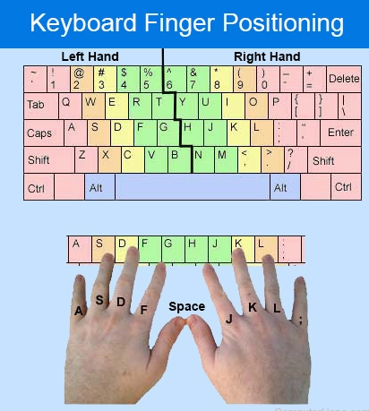

The left pinky (little) finger is placed over the "A" key and is also responsible for the second most keys on the keyboard, including the following keys.
- "`" (back quote) and when pressing Shift, the "~" (tilde)
- 1 and when pressing Shift, the "!" (exclamation mark)
- Tab
- Q
- Caps Lock
- A
- Left Shift
- Left Ctrl
- Z
- Fn key
The left ring finger is placed over the "S" key and is also responsible for the following keys.
- 2 and when pressing Shift, the "@" (at sign)
- W
- S
- X
The left middle finger is placed over the "D" key and is also responsible for the following keys.
- 3 and when pressing Shift, the "#" (hash)
- E
- D
- C
The left index finger is placed over the "F" key and is also responsible for the following keys.
- 4 and when pressing Shift, the "$" (dollar sign)
- 5 and when pressing Shift, the "%" (percent)
- R
- T
- F
- G
- V
- B
The right index finger is placed over the "J" key and is also responsible for the following keys.
- 6 and when pressing Shift, the "^" (caret)
- 7 and when pressing Shift, the "&" (ampersand)
- Y
- U
- H
- J
- N
- M
The right ring middle finger is placed over the "K" key and is also responsible for the following keys.
- 8 and when pressing Shift, the "*" (asterisk)
- I
- K
- , (comma) and when pressing Shift, the "<" (less than)
The right ring finger is placed over the "L" key and is also responsible for the following keys.
- 9 and when pressing Shift, the "(" (left or open parenthesis)
- O
- L
- "." (period) and when pressing Shift, the ">" (greater than)
The right pinky (little) finger is placed over the ";" key and is also responsible for the most keys on the keyboard, including the following keys.
- 0 and when pressing Shift, the ")" (right or close parenthesis)
- P
- ";" (semicolon) and when pressing Shift, the ":" (colon)
- "/" (forward slash) and when pressing the Shift, the "?" (question mark)
- "-" (hyphen) and when pressing Shift, the "_" (underscore)
- [ (left or open bracket) and when pressing Shift, the "{" (left or open curly bracket)
- ' (single quote) and when pressing Shift, the " (quote)
- Right Shift
- "=" (equals sign) and when pressing Shift, the "+" (plus sign)
- "]" (right or close bracket) and when pressing Shift, the "}" (right or close curly bracket)
- Backspace or Delete
- "\" (backslash) and when pressing Shift, the "|" (pipe)
- Enter
- Right Ctrl
Both thumbs are placed over the spacebar and may also be used for the following keys.
2.Body posture
We see too many workplace injuries that could be avoided. And prevention is better than cure. Here is a four-step checklist that you can carry out at your workstation, to make sure you’re comfortable, safe and productive at the office.
STEP 1: Your chair
- Adjust the seat height so your feet are flat on the floor and your knees equal to, or slightly lower than, your hips.
- Adjust the back of the chair to a 100°-110° reclined angle. Make sure your upper and lower back are supported.
- Adjust the armrests (if fitted) so that your shoulders are relaxed. If your armrests are in the way, remove them
STEP 2: Your keyboard
- Position the keyboard directly in front of your body.
- Determine what section of the keyboard you use most frequently, and readjust the keyboard so that section is centered with your body.
- Adjust the keyboard height so that your shoulders are relaxed, your elbows are in a slightly open position (100° to 110°), and your wrists and hands are straight.
STEP 3: Screen, Document, and Telephone
Incorrect positioning of the screen and source documents can result in difficult postures. Adjust the screen and source documents so that your neck is in a neutral, relaxed position.
- Centre the screen directly in front of you, above your keyboard.
- Position the top of the screen approximately 2-3” above seated eye level.
- Sit at least an arm’s length away from the screen and then adjust the distance for your vision.
STEP 4: Pauses and breaks
Once you have correctly set up your computer workstation use good work habits. No matter how perfect the environment, prolonged, static postures will inhibit blood circulation in your body.
- Take short 1-2-minute(s) stretch breaks every 20-30 minutes. After each hour of work, take a break or change tasks for at least 5-10 minutes. Always try to get away from your computer during lunch breaks.
- Avoid eye fatigue by resting and refocusing your eyes periodically. Look away from the monitor and focus on something in the distance.
3.Ergonomics

Computers have become very commonplace because of their versatility and efficiency. Many people spend hours on their computer every day.

Computer user requires a lot of repetitive movement. Unfortunately, this can cause discomfort and fatigue and even lead to irreversible Repetitive Strain Injuries(RSI).

- Start by checking that your chair and desk are well adjusted:
Chair
- Adjust the seat height so that your feet rest flat on the floor.
- Make sure that there is no pressure on back of the knees.
Desk
- Adjust the desk height so that your wrists can rest comfortably on it.
- Your forearms should be le el with the desk top and your upper and forearms should form a 90-degree angle or slightly more.

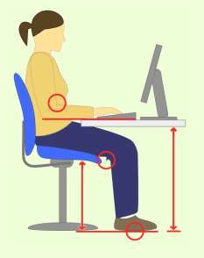

- Check that your display, keyboard and mouse are placed correctly.
Display
- Place the monitor directly in front of you at about an arm’s length away.
- Adjust the top of the computer screen to a little below eye level.
Keyboard and mouse
- Place the keyboard right in front of you, centered to the monitor.
- Place the mouse next to the keyboard on the same plane. When using the mouse, keep your wrist straight and your upper arm close to the body.

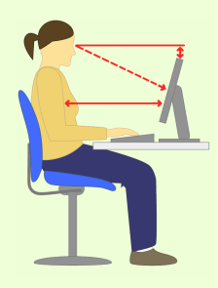

- Check your posture using list below.
- Sit up straight, thighs fully supported by the seat.
- Center your body in front of the keyboard and monitor.
- Place your feet firmly on the floor or on a footrest.
- Relax your shoulders and your elbows close to the body.
- Keep forearms and writs in a straight line (neutral position).
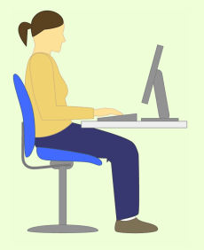

- Take short breaks. Get up from the chair, stretch and move around.

4.Typing speed
Typing speed is usually measured in Words per Minute, WPM.

The average typing speed is around 40 words per minute (wpm). If you want to be very productive, you should aim for a typing speed of 65 to 70 words per minute. That translates into between 190 and 200 characters per minute (CPM). However, professional typists type a lot faster, averaging between 65 and 75 WPM.

1.3.2 Use of typing master

Typing Master is the personal typing trainer that adapts to your unique needs. The program provides customized exercises and helpful feedback to guide you step by step to professional keyboarding. As a result, your typing speed will increase significantly saving you a lot of valuable work time. With this program you can:

- Check total number of words written per minute
- Maintain writing errors
- Games to improve typing speed
LO 2 Create web structures
2.1 Definition of general key terms
2.1.1 Webpage

A web page or webpage is a document, commonly written in HTML, that is viewed in an Internet browser. A web page can be accessed by entering a URL address into a browser's address bar. A web page may contain text, graphics, and hyperlinks to other web pages and files.
2.1.2 Website

A website is a collection of web pages and related content that is identified by a common domain name and published on at least one web server.

2.1.3 Web browser

A web browser is a software program that allows a user to locate, access, and display web pages. Web browser is usually shortened to "browser."
Web browsers are used primarily for displaying and accessing websites on the internet, as well as other content created using languages such as Hypertext Markup Language (HTML) and Extensible Markup Language (XML).
Some examples are: Microsoft edge, internet explorer, opera, torch, tor, safari, Google chrome, Mozilla Firefox, etc.
2.1.4 Text editor
Text editor is a software program that allows users to create or manipulate plain text computer files.
Some examples are: Notepad, Notepad++, Sublime text, Visual Studio Code (VS Code), brackets, etc.
2.1.5 URL

A URL (Uniform Resource Locator) is a unique identifier used to locate a resource on the Internet. It is also referred to as a web address. URLs consist of multiple parts including a protocol and domain name that tell a web browser how and where to retrieve a resource.
End users use URLs by typing them directly into the address bar of a browser or by clicking a hyperlink found on a webpage, bookmark list, in an email or from another application.
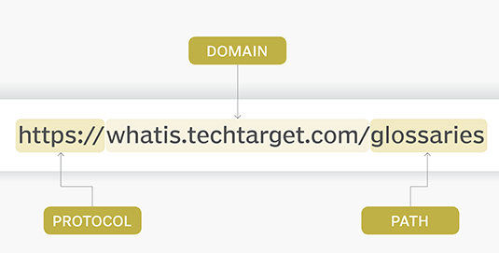

2.1.6 Hyperlink

A hyperlink is an element in an HTML document that links to either another portion of the document or to another document altogether. On webpages, hyperlinks are usually colored purple or blue and are sometimes underlined.

2.2 Setting up of text editor and web browser
2.2.1 Examples of text editor

The examples of text editor are atom, visual studio code, notepad++, vim, emacs, brackets, sublime text 3, etc.

2.2.2 Examples and function of web browser

The examples of web browser are: google chrome, safari, Microsoft edge, Mozilla Firefox, opera, internet explorer, Brave, etc.

Main functions of the internet browser

1. Sending requests to and retrieving data from the server

Internet browsers are used to fetch and retrieve hypertext mark-up text from the internet to the user device. It can be static like the HTML pages only or dynamic data like data from the form. When the user clicks a button or page it is retrieved from the server and the web browser displays the same content.

2. Displaying webpage content

Web browsers act as an interface for users to interact with web pages. Different internet browsers may display the same web page differently. This depends on how it is designed.
Designers are advised when designing a web page to use different browsers to test how the page will display to offer all users a friendly view from any browser that they will use. Also, different browsers support different font types that give a different view of the same document.

3. Provide navigation facilities for users
Navigation control is another function of the internet browser. All browsers have menus, tabs, and many other features that are used to navigate around the website and the internet generally. The browser allows users to open more than one web page, and print, and save pages among other features.

4. Caching of most frequently accessed data to increase browsing speed

The web browser saves the content that users retrieve regularly to save time when retrieving data from the server. Instead of getting the page from the server, it retrieves some components that were saved in the client computer for fast operation. The content or components that are saved are those that are less frequently changed. The period of data cached depends on how the browser is set.

2.2.3 Installing text editor and web browser

Installation from storage drive

Browse on the storage drive and choose the setup of text editor (eg. npp.8.4.6.Installer.x64) or web browser(eg.Tor browser)

The installation of Notepad++

- Click on the setup with double click or right click and then open
- Choose Yes to continue the installation
- Choose the language, by default is English
- Click on OK to continue the installation
- Click on Next to continue
- Click on I Agree button to agree the license agreement.
- Click on Next to continue
- Click on Next to continue
- Check the Cerate shortcut on Desktop and click on Install button
- Wait the few minutes for completed installation
- Click Finish button to end the installation.
The installation of Tor browser

- Click on the setup with double click or right click and then open
- Choose Run to continue the installation
- Choose the language, by default is English
- Click on OK to continue the installation
- Click on Next to continue
- Click on Install button to continue
- Wait the few minutes for completed installation
- Click Finish button to end the installation.

Installation from internet

Download the online installer of any application and then browse where it is located.

The installation from internet of Google Chrome

- Click on the setup with double click or right click and then open
- Choose Run to start the process of installation
- Wait for few minutes for downloading and installing Google Chrome
2.3 Creating a web page in HTML
2.3.1 Description of website
2.3.1.1 Types

1.eCommerce website

An eCommerce website is an online shop where people can buy products. Some businesses have both physical store locations and shops as well as eCommerce websites to reach a larger customer base. When your customer lives on the internet, you have an infinite amount of potential customers you can reach.

This is a popular website type for designers to work on. There are always new businesses starting up every single day and they’re looking for designers to help them create a memorable online presence to sell their products. As a web designer, you can choose to specialize in designing certain types of websites or work with certain clients.

When designing these websites, there are many factors to consider. Think about the brand presence and how to set their product apart from the competition. Organization is key, are there multiple families of products, maybe different flavors or sizes? With so much variety, it’s important to make sure the customer understands what they are buying.

2.Business website

A business website generally serves as a space to provide general information about your company or a direct platform for e-commerce.

3.Blog website

A blog is a website that’s regularly updated with articles, also called blog posts. These sites can be run by an individual, a group of people, or even companies. The purpose of a blog is to share information on a specific topic to attract an audience. Blogs are a space for people to share written and visual content about whatever they desire.

4.Portfolio website

A portfolio website is used to display and promote examples of someone’s past work. Mostly used by those who work within a creative field, a portfolio site is essentially a visual resume. It demonstrates your skills as a creative and shows your best work in hopes of attracting prospective clients or employers.

5.Social media websites
Facebook, Twitter, and Pinterest are examples of popular social media websites. They are usually created to allow people to share their own thoughts and ideas or simply connect with other people. These sites allow the user to upload words, photos, and videos to personalize their feeds. With automatic refresh and infinite scroll features, these sites tend to keep people coming back for new content often.
6.Video streaming websites
Video streaming websites like YouTube, Netflix, Hulu, Amazon Prime, and many other competitors have surged in popularity over the last decade. Some are free, while others offer paid services.
With so much traffic and bandwidth streaming, these websites require a lot of backend maintenance. Streaming companies tend to have their own in-house design and development teams that work on long-term updates.
7.Web portals
Web portals are often created for internal purposes for a business, organization, school, or institution. They usually involve a login with a personalized experience based on the user. For example, a university might have a web portal allowing students to access information about their courses or a company might use a portal to allow their employees to request time off and view pay stubs.
8.Personal website

The goal of a personal website is exactly that, personal. It might not be to sell something or promote work but merely to post and share thoughts. Often times it can feature a blog, maybe it’s a one-page resume with links to other social platforms, or whatever someone wants to share. You can create a personal website to promote your individuality and interests, such as fan websites or hobby websites.

9.Membership website

Membership websites use a paywall in order for a user to access the content. Usually, these are paid for on a monthly or yearly basis and are updated regularly with new content to keep the user coming back and happy to renew their membership.
10.Community forum website
Community forum websites provide an organized way to publish discussions on a specific topic. Users can register to start and contribute to existing discussions. Forums tend to help users solve technical issues, a great example of one is the WordPress support forum.
11.Event website

An event website is practically a cost-free digital advertisement for the event you're organizing.

12. Informational websites

Informational websites act as a resource to convey information. Examples include encyclopedias and news outlet websites. They often include long form content to satisfy reader curiosity and implement search functions, so visitors can find what they are looking for.

13.Nonprofit website

Nonprofit websites don't aim to sell products or services to their visitors, but they still need to convince people to support their cause.

2.3.1.2 Function

The functions of a website:
- Media for communication
Communication is a process of delivering information and usually, it is a two-way communication, which both parties are sending and receiving message to each other.
- Media for entertainment
Online gaming sites, online music sites, live stream sites and movies stream sites, are websites that provide content that are entertaining for their users.
- Media for Education
Sometimes, the information provided in a website can be used for learning purposes and it is appropriate to be distributed, such as information on politics, economics, science, social culture, and many more.
- Media for Business
Websites could also work as a media for promotion, marketing, and transactions. Websites can connect specific companies, consumers, and communities. A business could also expand their target market wider. They could spread their name to the entire world.

2.3.2 Introduction to HTML

HyperText Markup Language(HTML) is text markup language used to create HTML documents (web pages) for the Internet.HTML is a set of logical codes or tags(markup) that are used to define the web browser how to present the information in the web page.
It is interpreted by the web browser. The web browser is software that runs on the web client (user computer) and it interprets HTML tags to display the contents of the web page.
HTML is not considered as programming language because it can’t create dynamic functionality.
HTML was earlier proposed by Tim Berners Lee and developed by W3C (World Wide Web Consortium) and WHATWG (Web Hypertext Application Technology Working Group), and released in the year 1993. HTML has been extended from SGML (Standard Generalized Markup language). The filename extension of HTML is .html and .htm (file extension ` used for Disk operating system (DOS) and windows also). The last release of HTML is HTML5, a major release for HTML in 2014.

The HTML page structure is:

<!DOCTYPE html>
<html>
<head>
<title>Page Title</title>
</head>
<body>
…………
</body>
</html>

The explanation on this HTML file structure:

- The <!DOCTYPE html> declaration defines that this document is an HTML5 document
- The <html> element is the root element of an HTML page
- The <head> element contains meta information about the HTML page
- The <title> element specifies a title for the HTML page (which is shown in the browser's title bar or in the page's tab)
- The <body> element defines the document's body, and is a container for all the visible contents, such as headings, paragraphs, images, hyperlinks, tables, lists, etc.
The timeline of HTML is:
- 1991- Tim Berners-Lee invents HTML 1.0
- 1993- HTML 1.0 is released.
- 1995- HTML 2.0 is published. This contains the features of HTML 1.0 plus new features. This remained the standard markup language for designing and creating websites until 1997.
- 1997- HTML 3.0 was invented. Here, Dave Raggett introduced a fresh draft on HTML, which improved new features of HTML and gave more powerful characteristics for webmasters in designing websites.
- 1999- The widely used HTML 4.0 comes out. It is very successful.
- 2014- HTML 5.0 is released and used worldwide. It is said to be the extended version of HTML 4.01 which was published in 2012.
2.3.3 Description of HTML tag

2.3.3.1 Definition

HTML tags are simple instructions that tell a web browser how to format text.

HTML tags include tags for references, tags for tables, tags for headlines or titles, etc. An HTML tag consists of the tag name in angular brackets.

2.3.3.2 Types and examples

HTML tags can be of two types:
- paired tags
It is also called container tag. A tag is said to a paired tag if it along with a companion tag or closing tag appears at the end. In paired tag, first tag is called the opening tag and the second tag is called the closing tag. Some examples of paired tags are:<p>, <paragraph>, <html>, <title>, <head>, <body>, etc….
- singular tags
It is also known as a stand-alone tag or empty tag. It does not have companion tag or closing tag. Some examples of singular tags are:<br>, <hr><input>, <img>, etc….

2.3.3.3 Tag attributes

Attributes define additional characteristics of the element. Attributes are always specified in the start tag (or opening tag) and usually consists of name/value pairs like name="value”. Attribute values should always be enclosed in quotation marks.

2.3.4 Developing first simple webpage
2.3.4.1 Use HTML page structure

To create a simple webpage, you need to use the HTML page structure and add the contents which will be displayed in web browser. Those contents must be in the body section of HTML file.
Example: We need to create a web page for displaying L3 Software Development 2022-2023 as paragraph.
HTML file is:

<!DOCTYPE html>
<html>
<head>
<title>My first webpage</title>
</head>
<body>
<p><b>L3 Software Development 2022-2023</b></p>
</body>
</html>

2.3.4.2 Use HTML extension to save document

After writing these HTML codes in text editor you need to save it with .html.
2.3.4.3 Display contents using web browser

To display the content of HTML file, go to the location where your file is saved and then click on it to be displayed by default web browser or use right click, open with your desired web browser.
The output of the above code is

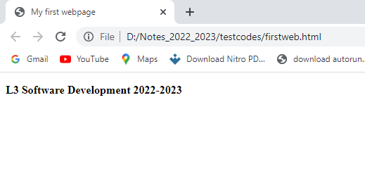

2.3.5 Developing webpage using HTML tag categories

2.3.5.1 Formatting tags
HTML formatting tags use for formatting a text style. It will become necessary to make minor changes to the formatting of those elements.
In HTML the formatting tags are divided into two categories:
- Physical tag: These tags are used to provide the visual appearance to the text.
- Logical tag: These tags are used to add some logical or semantic value to the text.
Following is the list of HTML formatting text.
Tag | Description
<b> | This is a physical tag, which is used to bold the text written between it.
<strong> | This is a logical, which tells the browser that the text is important.
<i> | This is a physical tag which is used to make text italic.
<em> | This is a logical tag which is used to display content in italic.
<mark> | This tag is used to highlight text.
<u> | This tag is used to underline text written between it.
<sup> | It displays the content slightly above the normal line.
<sub> | It displays the content slightly below the normal line.
<del>,<s>,<strike> | This tag is used to display the deleted content.
<ins> | This tag displays the content which is added
<big> | This tag is used to increase the font size by one conventional unit.
<small> | This tag is used to decrease the font size by one unit from base font size.

2.3.5.2 Table tags

To create a table in HTML you will need to use tags. The most important one is the <table> tag which is the main container of the table. It shows where the table will begin and where it ends.

Other tags include:
- <tr> represents rows
- <td> is used to create data cells
- <th> is used to add table headings
- <caption> is used to insert captions
- <thead> adds a separate header to the table
- <tbody> shows the main body of the table
- <tfoot> creates a separate footer for the table
2.3.5.3 Form tags

An HTML form facilitates the user to enter data that is to be sent to the server for processing such as name, email address, password, phone number, etc.HTML forms are required if you want to collect some data from the site visitor.

The HTML <form> element provide a document section to take input from user. It provides various interactive controls for submitting information to web server such as text field, text area, password field, etc.

The <form> element does not itself create a form but it is container of all required form elements, such as <input>, <label>, etc.

Syntax:
<form>
//Form elements
</form>
Other tags that are used with <table> tag are:

The HTML <input> element is fundamental form element. It is used to create form fields, to take input from user. We can apply different input filed to gather different information from user.

This example to show the simple text input.

<body>
<form>
Enter your name <br>
<input type="text" name="username">
</form>
</body>

HTML Form Input Types

In HTML <input type=" "> is an important element of HTML form. The "type" attribute of input element can be various types, which defines information field.

Following is a list of all types of <input> element of HTML

Value | Description
Text | Defines a one-line text input field
Password | Defines a one-line password input field
Submit | Defines a submit button to submit the form to server
Reset | Defines a reset button to reset all values in the form
Radio | Defines a radio button which allows select one option
Checkbox | Defines checkboxes which allow to select multiple options
Button | Defines a simple push button, which can be programmed to perform a task on an event.
File | Defines to select the file from device storage.
Image | Defines a graphical submit button
Date | Defines an input field for selection of date
Email | Defines an input field for entering an email address
Number | Defines an input field to enter a number
Tel | Defines an input field for entering the telephone number

The <textarea> tag in HTML is used to insert multiple-line text in a form. The size of <textarea> can be specify either using "rows" or "cols" attribute.

Example:

<!DOCTYPE html>
<html>
<head>
<title>Form in HTML</title>
</head>
<body>
<form>
Enter your address:<br>
<textarea rows="2" cols="20"></textarea>
</form>
</body>
</html>

The <label> tag in form is considered better to have label in form. As it makes the code parser/browser/user friendly.
If you click on the label tag, it will focus on the text control. To do so, you need to have for attribute in label tag that must be same as id attribute of input tag.
It is good to use <label> tag with form, although it is optional but if you will use it, then it will provide a focus when you tap or click on label tag. It is more worthy with touchscreens.

Example:

<form>
<label for="firstname">First Name: </label> <br/>
<input type="text" id="firstname" name="firstname"/> <br/>
<label for="lastname">Last Name: </label>
<input type="text" id="lastname" name="lastname"/> <br/>
</form>

The <fieldset> element in HTML is used to group the related information of a form. This element is used with <legend> element which provide caption for the grouped elements.

Example:

<form>
<fieldset>
<legend>User Information:</legend>
<label for="name">Enter name</label><br>
<input type="text" id="name" name="name"><br>
<label for="pass">Enter Password</label><br>
<input type="Password" id="pass" name="pass"><br>
<input type="submit" value="submit">
</fieldset>
</form>

The <select> tag defines a drop-down list.

The <option> tag defines an option in a drop-down list.

Example:

<select name="cars" id="cars">
<option value="volvo">Volvo</option>
<option value="saab">Saab</option>
<option value="mercedes">Mercedes</option>
<option value="audi">Audi</option>
</select>

The <optgroup> tag defines a group of related options in a drop-down list.
Example:

<select name="cars" id="cars">
<optgroup label="Swedish Cars">
<option value="volvo">Volvo</option>
<option value="saab">Saab</option>
</optgroup>
<optgroup label="German Cars">
<option value="mercedes">Mercedes</option>
<option value="audi">Audi</option>
</optgroup>
</select>

The <button> tag defines a clickable button.

Example:

<button type="button" onclick="alert('Hello world!')">Click Me!</button>

2.3.5.4 Heading tags
HTML header tag h1 is used for specifying heading level 1. There are 6 levels of headings (h1 - h6) with h1 the most important and h6 the least important.
Browsers are supported various headings in different sizes - with h1 being the largest and h6 being the smallest.
Example:

<html>
<head>
<title>HTML Heading Tag</title>
</head>
<body>
<h1>Heading h1<h1>
<h2>Heading h2<h2>
<h3>Heading h3<h3>
<h4>Heading h4<h4>
<h5>Heading h5<h5>
<h6>Heading h6<h6>
</body>
</html>

2.3.5.5 List tags
HTML Lists are used to specify lists of information. All lists may contain one or more list elements. There are three different types of HTML lists:
- Ordered List or Numbered List (ol)
- Unordered List or Bulleted List (ul)
- Description List or Definition List (dl)
a) HTML Ordered List or Numbered List
In the ordered HTML lists, all the list items are marked with numbers by default. It is known as numbered list also. The ordered list starts with <ol> tag and the list items start with <li> tag.
Example:
<ol>
<li>Aries</li>
<li>Bingo</li>
<li>Leo</li>
<li>Oracle</li>
</ol>
To represent different ordered lists, there are 5 types of attributes in <ol> tag.
Type | Description
Type="1" | This is the default type. In this type, the list items are numbered with numbers.
Type="I" | In this type, the list items are numbered with upper case roman numbers.
Type="i" | In this type, the list items are numbered with lower case roman numbers.
Type="A" | In this type, the list items are numbered with upper case letters.
Type="a" | In this type, the list items are numbered with lower case letters.

b) HTML Unordered List or Bulleted List
In HTML Unordered list, all the list items are marked with bullets. It is also known as bulleted list also. The Unordered list starts with <ul> tag and list items start with the <li> tag.
Example:
<ul>
<li>Aries</li>
<li>Bingo</li>
<li>Leo</li>
<li>Oracle</li>
</ul>

c) HTML Description List or Definition List
HTML Description list is also a list style which is supported by HTML and XHTML. It is also known as definition list where entries are listed like a dictionary or encyclopedia.
The definition list is very appropriate when you want to present glossary, list of terms or other name-value list.
The HTML definition list contains following three tags:
- <dl> tag defines the start of the list.
- <dt> tag defines a term.
- <dd> tag defines the term definition (description).
Example:
<dl>
<dt>Aries</dt>
<dd>-One of the 12 horoscope sign. </dd>
<dt>Bingo</dt>
<dd>-One of my evening snacks</dd>
<dt>Leo</dt>
<dd>-It is also an one of the 12 horoscope sign. </dd>
<dt>Oracle</dt>
<dd>-It is a multinational technology corporation. </dd>
</dl>

2.3.5.6 Media tags

The media tags are:
- <audio>: It is an inline element that is used to embed sound files into a web page.
Syntax:

<audio>
<source src="sample.mp3" type="audio/mpeg">
</audio>

Example:

<!DOCTYPE html>
<html>
<head>
<title>My first webpage</title>
</head>
<body>
<audio controls>
<source src="yesu_mureba.mp3" type="audio/mpeg">
</audio>
</html>

- <video>: It is used to embed video files into a web page.

Syntax:

<video src="" controls> </video>
Example:
<!DOCTYPE html>
<html>
<head>
<title>My first webpage</title>
</head>
<body>
<video src="arakiza.mp4" type="video/mp4" controls width="200" height="200"></video>
</body>
</html>

- <source>: It is used to attach multimedia files like audio, video, and pictures.

Syntax:

<source src="" type="">
...
</source>

Example:

<!DOCTYPE html>
<html>
<head>
<title>My first webpage</title>
</head>
<body>
<audio controls>
<source src="yesu_mureba.mp3" type="audio/mpeg">
</audio>
</html>

- <embed>: It is used for embedding external applications which are generally multimedia content like pdf file, audio or video into an HTML document.
Syntax:

<embed attributes>

Example:

<!DOCTYPE html>
<html>
<head>
<title>My first webpage</title>
</head>
<body>
<video>
<embed src="audio.mp3" type="audio/mpeg" width="300" height="50">
</video>

</body>
</html>

- <track>: It specifies text tracks for media components audio and video.
The <track> tag is used inside <video> or <audio> elements to add:
- Subtitles
- Captions
- Descriptions
- Chapters

Syntax:

<track attribute>

Example:

<video controls>
<source src="movie.mp4" type="video/mp4">
<track src="subtitles.vtt" kind="subtitles" srclang="en" label="English">
</video>

2.3.5.7 Code tags

1.<code> tag is used to define a piece of computer code. The content inside is displayed in the browser’s default monospace font.
Example:

<p>The HTML <code>button</code> tag defines a clickable button. </p>
2.<samp> tag defines sample output from a computer program.
Example:
<p><samp>File not found. <br>Press F1 to continue</samp></p>
3.<kbd> tag defines keyboard input.
Example:
<p>Press <kbd>Ctrl</kbd> + <kbd>C</kbd> to copy text (Windows).</p>
4.<var> tag defines a variable.
Example:
<p>The area of a triangle is: 1/2 x <var>b</var> x <var>h</var>, where <var>b</var> is the base, and <var>h</var> is the vertical height. </p>
5.<pre> tag defines preformatted text.
Example:
<pre>
Levels in Software Development
</pre>
Levels in Accounting
</body>

2.3.5.8 HTML frame tags
HTML <frame> tag define the particular area within an HTML file where another HTML web page can be displayed.
A <frame> tag is used with <frameset>, and it divides a webpage into multiple sections or frames, and each frame can contain different web pages.
Note: Do not use HTML <frame> tag as it is not supported in HTML5, instead you can use <iframe>

Syntax
< frame src = "URL" >

Create Vertical frames:
<!DOCTYPE html>
<html>
<head>
<title>Frame tag</title>
</head>
<frameset cols="25%,50%,25%">
<frame src="frame1.html" >
<frame src="frame2.html">
<frame src="frame3.html">
</frameset>
</html>

Create Horizontal frames:
<!DOCTYPE html>
<html>
<head>
<title>Frame tag</title>
</head>
<frameset rows="30%, 40%, 30%">
<frame name="top" src="frame1.html" >
<frame name="main" src="frame2.html">
<frame name="bottom" src="frame3.html">
</frameset>
</html>

<iframe src=""></iframe>

2.3.5.9 HTML Comment

We use <!--...--> tag for giving the HTML comment.

The comment tag is used to insert comments in the source code. Comments are not displayed in the browsers.

You can use comments to explain your code, which can help you when you edit the source code at a later date. This is especially useful if you have a lot of code.

Example:

<!DOCTYPE html>
<html>
<body>

<!-- This is a comment -->
<p>This is a paragraph.</p>
<!-- Comments are not displayed in the browser -->

</body>
</html>

2.3.5.10 Grouping tags (div, span)

1.Div tag

The div tag is known as Division tag. The div tag is used in HTML to make divisions of content in the web page like (text, images, header, footer, navigation bar, etc). Div tag has both open(<div>) and closing (</div>) tag and it is mandatory to close the tag. The Div is the most usable tag in web development because it helps us to separate out data in the web page and we can create a particular section for particular data or function in the web pages.
- Div tag is Block level tag
- It is a generic container tag
- It is used to the group of various tags of HTML so that sections can be created and style can be applied to them.
As we know Div tag is block-level tag in this example div tag contain entire width. It will be displayed div tag each time on a new line, not on the same line.
Example:
<!DOCTYPE html>
<html>
<head>
<style>
.myDiv {
border: 5px solid red;
background-color: lightblue;
text-align: center;
}
</style>
</head>
<body>

<h1>The div element</h1>

<div class="myDiv">
<h2>This is a heading in a div element</h2>
<p>This is some text in a div element. </p>
</div>

<p>This is some text outside the div element. </p>

</body>
</html>

2.span tag

The HTML span element is a generic inline container for inline elements and content. It is used to group elements for styling purposes (by using the class or id attributes), A better way to use it when no other semantic element is available.
The span tag is a paired tag means it has both open (<) and closing (>) tags, and it is mandatory to close the tag. The span tag is used for the grouping of inline elements & this tag does not make any visual change by itself. span is very similar to the div tag, but div is a block-level tag and span is an inline tag.

Syntax:
<span class="">Some Text</span>
Example:
<p>My mother has <span style="color:blue">blue</span> eyes.</p>

2.3.6 Use of Hyperlinks

A hyperlink is a clickable word, phrase, or image on the internet that leads from one web page to another.

To create a hyperlink, we use <a> tag.
1.Syntax

<a href="url">link text</a>

The most important attribute of the <a> element is the href attribute, which indicates the link's destination. The link text is the part that will be visible to the reader.
2.Default link appearance
By default, links will appear as follows in all browsers:
- An unvisited link is underlined and blue
- A visited link is underlined and purple
- An active link is underlined and red
3.Types
- Internal links
Internal links are hyperlinks that direct the readers to a target page on your website. Internal link is a link from one page to another page on the same domain.
- External links
External links are that which wants customers clicking on links that directs them away from your website.
2.3.7 Use of HTML graphics

2.3.7.1 Canvas tags

The <canvas> tag in HTML is used to draw graphics on a web page using JavaScript. It can be used to draw paths, boxes, texts, gradients, and adding images. A canvas is a rectangular area on an HTML page. By default, it does not contain borders and text.
Note: The <canvas> tag is new in HTML5. Always specify an id attribute (to be referred to in a script), and a width and height attribute to define the size of the canvas. To add a border, use the style attribute.
Syntax:
<canvas id = "script"> Contents... </canvas>
Example 1:
<!DOCTYPE html>
<html>
<body>

<!-- canvas Tag starts here -->
<canvas id = "level" width = "200"height = "100" style = "border:1px solid black">
</canvas>
<!-- canvas Tag ends here -->

</body>
</html>
Output:
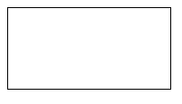

Example 2:

<!DOCTYPE html>
<html lang="en">

<head>
<meta charset="UTF-8">
<meta name="viewport" content="width=device-width, initial-scale=1.0">
<title>JavaScript - Drawing a Line</title>
</head>

<body>
<canvas id="canvas" height="400" width="500">
</canvas>
<script>

var c = document.getElementById("canvas");
var ctx = c.getContext("2d");
ctx.strokeStyle='red';
ctx.lineWidth=5;
ctx.beginPath();
ctx.moveTo(100,100);
ctx.lineTo(300, 100);
ctx.stroke();
</script>

</body>

</html>
Output:
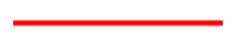

Example 3:

<!DOCTYPE html>
<html>
<body>

<canvas id="myCanvas" width="300" height="150" style="border:1px solid #d3d3d3;">
Your browser does not support the HTML5 canvas tag.</canvas>

<script>
var c = document.getElementById("myCanvas");
var ctx = c.getContext("2d");
ctx.beginPath();
ctx.moveTo(20, 20);
ctx.bezierCurveTo(20, 100, 100, 100, 100, 20);
ctx.stroke();
</script>

</body>
</html>
Output:
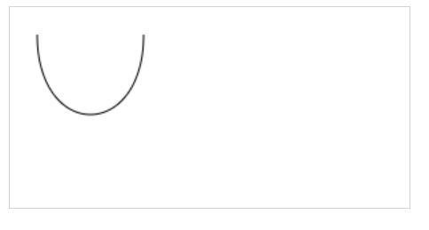

Example 4:

<!DOCTYPE html>
<html>

<body>
<!-- HTML code to illustrate canvas tag -->
<canvas id = "geeks" height = "200" width = "200"
style = "border:1px solid black">
</canvas>

<script>
var c = document.getElementById("geeks");
var cx = c.getContext("2d");
cx.beginPath();
cx.arc(100, 100, 90, 0, 2 * Math.PI);
cx.stroke();
</script>

</body>
</html>
arc(x, y, radius, startAngle, endAngle)

Output:
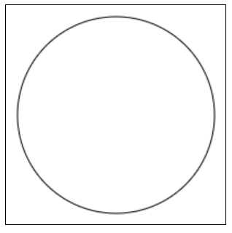

Example 5:

<!DOCTYPE html>
<html>
<body>

<!-- canvas tag starts here -->
<canvas id = "geeks" width = "200" height = "200"
style = "border:1px solid black">
</canvas>
<!-- canvas tag ends here -->

<script>
var c=document.getElementById("geeks");
var cx = c.getContext("2d");
var grd = cx.createRadialGradient(100,
100, 5, 100, 100, 100);
grd.addColorStop(0, "red");
grd.addColorStop(1, "green");
cx.fillStyle = grd;
cx.fillRect(0, 0, 200, 200);
</script>

</body>
</html>
Output:
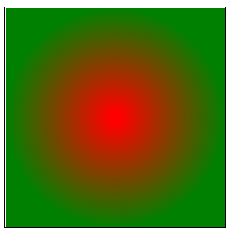
context.createRadialGradient(x0,y0,r0,x1,y1,r1);

x0: The x-coordinate of the starting circle of the gradient, y0: The y-coordinate of the starting circle of the gradient, r0: The radius of the starting circle, x1: The x-coordinate of the ending circle of the gradient, y1: The y-coordinate of the ending circle of the gradient, r1: The radius of the ending circle.

2.3.7.2 SVG tags
The <svg> tag defines a container for SVG (Scalable Vector Graphics) graphics. SVG is used to define vector-based graphics for the Web.
SVG has several methods for drawing paths, boxes, circles, text, and graphic images.
Example1:

<svg width="400" height="200">
<rect x="100" y="20" width="200" height="150"
fill="blue" stroke="pink" stroke-width="5"/>
</svg>

Output:
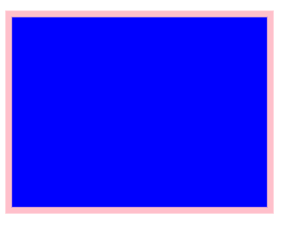

Example2:

<svg width="400" height="200">
<circle cx="150" cy="100" r="80" stroke="green" stroke-width="4" fill="red" />
</svg>
The explanation of some attributes:
- The cx and cy attributes define the x and y coordinates of the center of the circle. If cx and cy are omitted, the circle's center is set to (0,0)
- The r attribute defines the radius of the circle
Output:
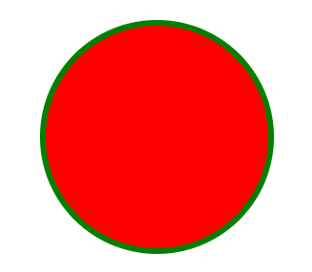
Example3:

<svg width="400" height="200">
<ellipse cx="200" cy="80" rx="100" ry="50" fill="blue" stroke="pink" stroke-width="5"/>
</svg>
The explanation of some attributes:
- The cx attribute defines the x coordinate of the center of the ellipse
- The cy attribute defines the y coordinate of the center of the ellipse
- The rx attribute defines the horizontal radius
- The ry attribute defines the vertical radius
Output:
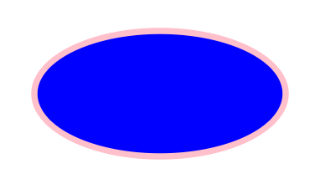

Example4:

<svg width="400" height="200">
<line x1="0" y1="0" x2="200" y2="200" fill="blue" stroke="pink" stroke-width="3"/>
</svg>
The explanation of some attributes:
- The x1 attribute defines the start of the line on the x-axis
- The y1 attribute defines the start of the line on the y-axis
- The x2 attribute defines the end of the line on the x-axis
- The y2 attribute defines the end of the line on the y-axis
Output:
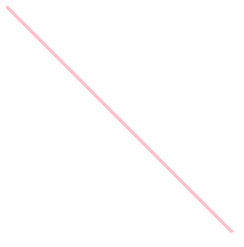
Example5:

<svg width="600" height="600">
<polygon points="30,10 40,50 50,20" fill="blue" stroke="pink" stroke-width="2"/>
</svg>
The explanation:
- The points attribute defines the x and y coordinates for each corner of the polygon
Output:
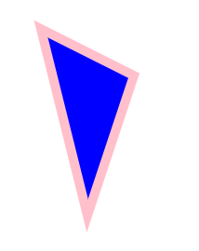
Example6: The <polyline> element is used to create any shape that consists of only straight lines (that is connected at several points)

<svg width="600" height="600">
<polyline points="20,20 40,25 50,30 60,40" stroke="black" fill="none"/>
</svg>

The points attribute defines the list of points (pairs of x and y coordinates) required to draw the polyline
Output:
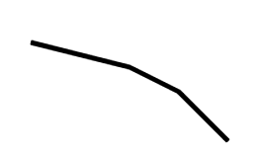

Example7: The <text> element is used to define a text.

<svg height="300" width="600">
<text x="20" y="50" fill="green" stroke="yellow" stroke-width="1" font-size="40">Welcome in GS BUMBA TSS</text>

</svg>
Output:

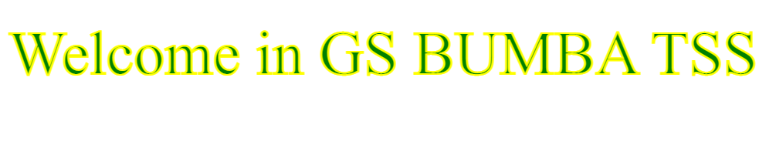
2.4 Managing page layout in HTML
2.4.1 Definition of page layout

Page layout refers to the arrangement of text, images, and other objects on a page.

2.4.2 Parts of webpage

The main parts of webpage are:
1.Header
Header is located at the top of a webpage. It can include the company logo, a title and sometimes a search box for the site. The header usually stays consistent for all webpages on a website.
2. Global navigation
It is also called main navigation generally represents the top-level pages of a site's structure. The role is:
- The main navigation provides an overview and answers important questions users may have when first coming to a site, such as "does this site have what I'm looking for?"
- The main navigation aids in orientation. It is comforting to have a persistent navigation mechanism across the site, particularly for large, information-rich sites.
- It allows people to switch topics. Visitors can get to other sections of a site efficiently, or they can reset their navigation path and start over using main navigation options.
- It helps when users get interrupted while navigating and reminds visitors where they are in a site.
- Main navigation gives shape to a site. In many ways, the main navigation defines the boundaries of the site itself.
3. Local Navigation
Local navigation is used to access lower levels in a structure, below the main navigation pages. The term "local" implies "within a given category." On a given page, local navigation generally shows other options at the same level of a hierarchy, as well as the options below the current page.
Local navigation often works in conjunction with a global navigation system and is really an extension of the main navigation. Because local navigation varies more often than main navigation, it is often treated differently.
4. Banner ads
They are the locations on webpage used for displaying the advertisement banners that can be shown in different places on a web page and are used to help pay for the expenses of running a website and company. Typically, ad banners will be found at the top, left, right, or bottom of a page and may also be included in the content.


5. Contact Information
Contact information can be located on webpage in the following ways:
- The phone number and email address in the footer area or
- A link 'Contact' or 'Contact us' in the footer area or on the navigation bar.
This figure shows the different elements of contact information

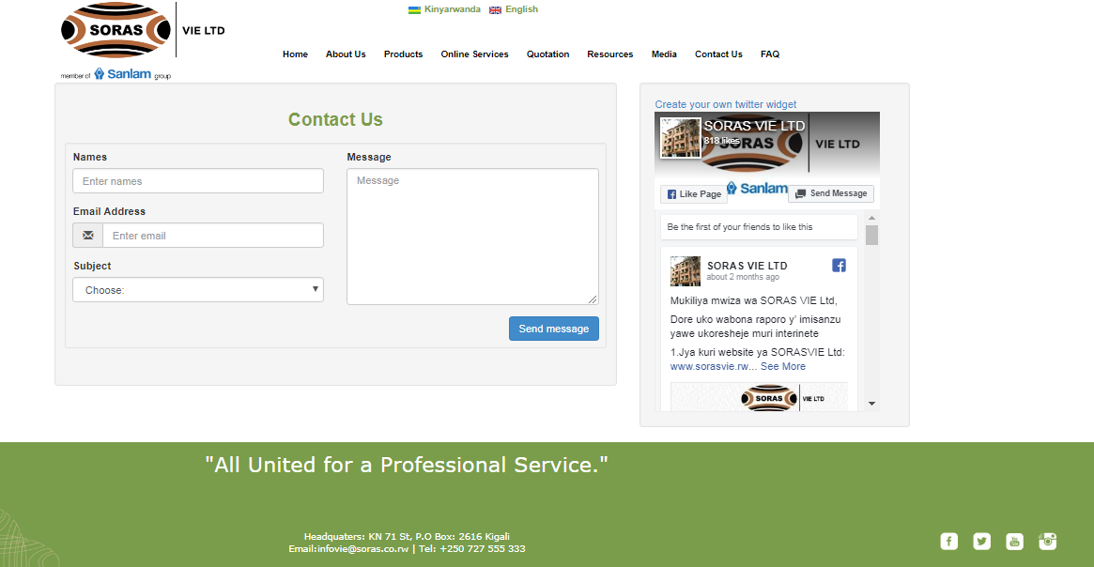

6. Content Area
The content area on a page is traditionally located to the left or right of a sidebar or between two sidebars. It provides main page information you want a visitor to focus on. The content area features a main title and content formatted into concise text paragraphs, images, videos or combination elements divided by spaces or subheadings.
This is the big area in the center that contains most of the unique content of a web page, for example the photo gallery you want to display or a feature article you want your visitors to read. This is area that changes from page to page.
7. Footer
It is located at the bottom of the page and usually provides links to contact information, company address, company information, terms of service, and social media links.

2.4.3 Use HTML tags to organize page layout

HTML has several semantic elements that define the different parts of a web page:

- <header> defines a header section on a page or a section of a page

A <header> element typically contains:

- one or more heading elements (<h1> - <h6>)
- logo or icon
- authorship information
Note: You can have several <header> elements in one HTML document. However, <header> cannot be placed within a <footer>, <address> or another <header> element.

- <nav> creates a container for navigation links
- <main> creates a container for the main content of the page
There must not be more than one <main> element in a document. The <main> element must not be a descendant of an <article>, <aside>, <footer>, <header>, or <nav> element.

- <section> defines a section in a document
- <article> defines an independent, self-contained content
- <aside> defines content aside from the content (like a sidebar)
- <footer> defines a footer section on a page or a section of a page
A <footer> element typically contains:

- authorship information
- copyright information
- contact information
- sitemap
- back to top links
- related documents
You can have several <footer> elements in one document.
- <details> defines additional details that the user can open and close on demand.
2.5 Optimizing webpage in HTML
2.5.1 Definition of optimization

Website optimization is the process of improving your website’s performance across various areas, such as web traffic, and usability.
Webpage optimization is the process of improving a webpage to make it:
- Faster
- Search engine friendly
- User-friendly
- Accessible to all users

Search Engine Optimization (SEO) refers to the practice of optimizing a website to improve its visibility and ranking on search engine results pages (SERPs) such as Google, Bing, and Yahoo.

The Search Engine Results Page (SERP) is the page that a search engine returns after a user submits a search query.
2.5.2 Benefit of applying SEO on webpage

SEO stands for search engine optimization, which is the process of improving your site to increase organic visibility for specific search queries.
The goal of SEO is to improve the quality and quantity of traffic to your website through onsite changes. This doesn’t mean just stuffing pages with relevant keywords, but focusing on core web vitals such as site speed, mobile-friendliness, interactivity, and the content of web pages.

Increased Visibility: Higher rankings in search results lead to more visibility and organic traffic. Cost-Effective: Compared to paid advertising, SEO provides a cost-effective way to attract long-term, sustainable traffic.
Credibility and Trust: Websites that appear at the top of search results are often perceived as more credible and trustworthy.
User Experience: Good SEO practices improve the overall user experience, making the website more user-friendly and efficient.
Competitive Advantage: Effective SEO can give a website an edge over competitors by attracting more visitors and potential customers.

2.5.3 Use HTML tags to optimize webpage

HTML tags are code elements with the back-end of all web pages, but there are also specific HTML code types which provide search engines with key information for Search Engine Results Page (SERP) display.

Basically, these elements highlight parts of your content that are relevant for search, and they describe those elements for search crawlers.

1.Meta

Meta description tag is used to Provides information about the webpage. Watch the length, Google will keep the first 150-160 characters of your meta description, and cut the rest.

Example:

=

2.Title
Title tag is used to set up those clickable headlines that you see in the Search Engine Results Page. Google creates a Search Engine Results Page headline for your page, and it could use any of the section headings from within the page or it may even create a new headline altogether.
- Watch the length - Google will only display the first 50-60 characters of your title, and cut the rest. It’s not a problem to have a title that’s longer than 60 characters.
- Include a reasonable number of keywords - Keyword stuffing is likely to get penalized, but one or two keywords will be fine.
- Write good copy -Create descriptive titles that highlight the value of your content, and set up proper expectations, so that users aren’t let down when they visit the page.
- Add your brand name - If you have a recognizable brand that’s likely to increase your click-through, then feel free to add it to the title as well.
Example:

3.Heading

Heading(H1-H6) tags are used to structure your pages for both the reader and search engines.
From the viewpoint of the search engine, however, heading tags form the core of the content, and help search crawler bots understand what the page is about.
The rules for headings are derived from the general copywriting practices :
- Don’t use more than one H1 - H1 heading stands apart from other headings because it’s treated by search engines as the title of the page.
- Maintain shallow structure - There’s rarely a need to go below H3. Use H1 for the title, H2 for section headings, and H3 for subsections. Anything more tends to get confusing. ​
- Be consistent with all headings - All of your headings should be written in such a way that if you were to remove all the text and keep only the headings, they would read like a list.
Example:
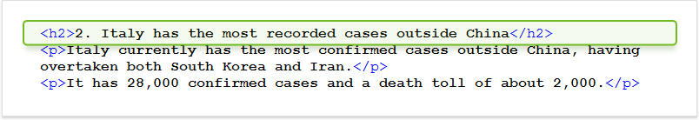

4.Image alt

The main goal of alt text is to describes an image.
The key goal of image alt text is to help users understand the image when it cannot be viewed with a visitor who is vision impaired.
Once you’ve created your list, apply these guidelines:
- Be concise, but descriptive - Good alt text is about a line or two of text that would help a visually impaired person understand what’s pictured. ​
- Don’t be too concise - One word, or even a few words, are probably not going to cut it - there would be no way to differentiate the image from other images.
Example:
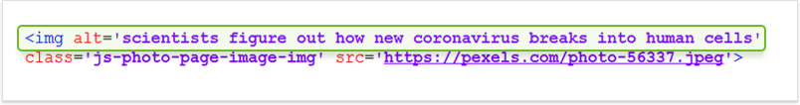

5.HTML semantic tags
HTML5 elements are used for better descriptions of various page components:
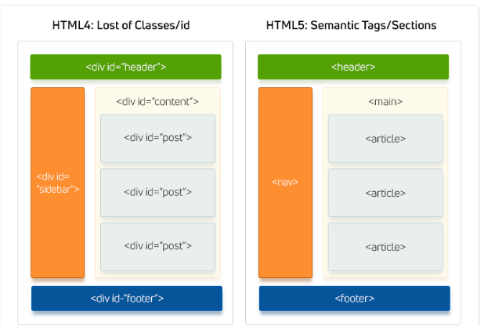

2.5.4 Web accessibility
Web accessibility means that websites are designed and developed so that people with disabilities can use them. More specifically, people can:
- perceive, understand, navigate, and interact with the Web

Html Role in Web Accessibility (ARIA Roles)
- HTML (Hypertext Markup Language) plays a crucial role in web accessibility by providing the web structural that ensures content is accessible to all users, including those with disabilities
- ARIA (Accessible Rich Internet Applications) roles improve accessibility

Test and Standard Validation
After creating a webpage, it must be tested and validated.
- Manual Testing: Manual testing involves human testers evaluating a website for accessibility issues
- Keyboard Navigation Testing: Ensuring all functionality is accessible using a keyboard alone, without a mouse.
- Color Contrast Testing: Checking color contrast ratios to ensure text is readable for users with visual impairments.
- Content Structure Testing: Reviewing the use of headings, lists, and other semantic elements to ensure a logical structure.
Tools for Manual Testing:
- WAVE: A web accessibility evaluation.
- Axe DevTools: A browser extension that helps identify and resolve accessibility issues.
- Chrome DevTools Accessibility: Built-in tools in Chrome
- Automatic Testing: Automated tools can quickly scan a website and identify many accessibility issues.
Popular Automated Testing Tools
Lighthouse: An open-source tool included in Chrome DevTools for auditing web pages for accessibility.
Axe: A comprehensive accessibility testing engine that integrates with various development tools.
Tenon: A web-based tool that checks for compliance with accessibility standards.
- User Testing: Involving users with disabilities in the testing process is invaluable
Types of User Testing:
Observational Testing: Watching users as they interact with your website.
Feedback Sessions: Gathering feedback from users about their experience

🔹 Validation Means:
Checking if HTML code follows official standards.
You can validate HTML using:
- World Wide Web Consortium (W3C) Validator

LO 3 STYLE WEB ELEMENTS
3.1 Introduction to CSS
3.1.1 Definition
Cascading Style Sheet(CSS) is used to set the style in web pages that contain HTML elements.

3.1.2 Utility
Cascading Style Sheets is a style sheet language which is used to describe the look and formatting of a document written in markup language.

3.1.3 Types
There are four types of CSS which are given below:
- Inline CSS
- Internal or Embedded CSS
- External CSS
- Imported CSS

3.2 Creating CSS files
3.2.1 CSS syntax

A CSS Syntax rule consists of a selector, property, and its value.

Purpose of CSS
The primary purpose of CSS is to separate the content of a web page from its presentation. This separation allows web designers and developers to change the appearance of a website without altering its underlying HTML structure.
Syntax: selector {Property: value;}

Example:
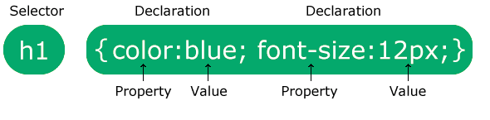
3.2.1.1 Selector

A CSS selector is the first part of a CSS Rule. It is a pattern of elements and other terms that tell the browser which HTML elements should be selected to have the CSS property values inside the rule applied to them.

The selector points to the HTML element where CSS style is to be applied.

3.2.1.2 Declaration

A declaration is the key-value pair of a CSS property and its value. CSS declarations are used to set style properties and construct rules to apply to individual or groups of elements. The property name and value are separated by a colon, and the entire declaration must be terminated by a semi-colon.

3.2.2 Use of CSS style types
3.2.2.1 Inline

Inline CSS contains the CSS property in the body section attached with element. This kind of style is specified within an HTML tag using the style attribute.
Example:

<!DOCTYPE html>
<html>
<head>
<title>Inline CSS</title>
</head>

<body>
<p style = "color:#00FF00; font-size:50px;font-style:italic; text-align:center;">
RUNDA TSS
</p>

</body>
</html>
3.2.2.2 Internal
An internal CSS is used to define a style for a single HTML page. It is defined in the <head> section of an HTML page, within a <style> element.
Example:

<!DOCTYPE html>
<html>
<head>
<title>Internal CSS</title>
<style>
p{
color:#00FF00;
font-size:50px;
font-style:italic;
text-align:center;
}
</style>
</head>

<body>
<p>KAGEYO TSS</p>

</body>
</html>

3.2.2.3 External

External CSS contains separate CSS file which contains only styles with .css extension and should be linked to the HTML document using link tag. This means that for each element, style can be set only once and that will be applied across web pages.

Example: The file given below contains styles. This file save with .css extension. For Ex: bumba.css

p{
color:#00FF00;
font-size:50px;
font-style:italic;
text-align:center;
}

Below is the HTML file that is making use of the created external style sheet
- link tag is used to link the external style sheet with the html webpage.
- href attribute is used to specify the location of the external style sheet file.

<!DOCTYPE html>
<html>
<head>
<title>External CSS</title>
<link rel="stylesheet" href="bumba.css"/>
</head>

<body>
<p>RUNDA TSS</p>

</body>
</html>
3.2.2.4 Imported

The @import rule is used to import one style sheet into another style sheet. The @import rule must be declared at the top of the document after any @charset declaration.
Syntax:
@import url(URL);
Example:

The first file with the CSS styles called runda.css
p{
color:#00FFFF;
font-size:50px;
font-style:italic;
text-align:center;
}
The second file with the CSS styles and @import rule called runda1.css

@import url("bumba.css");
h1 {
color: #00ff00;
}

or

@import "bumba.css";
h1 {
color: #00ff00;
}

The HTML file called imported.html

<!DOCTYPE html>
<html>
<head>
<title>imported CSS</title>
<link href="runda1.css" rel="stylesheet">
</head>

<body>
<p>RUNDA TSS</p>
<h1>Level 3 SOD</h1>
</body>
</html>
3.2.3 Use CSS Visual rules
3.2.3.1 Font

The CSS font properties are used for defining the size, font family, boldness and the style of the text.

Font Family

For the font family of the text we use font-family property. This is the name of the font, which we want to use in our webpage.
Example:
p {
font-family: Arial, sans-serif;
}

As you see we have given to our <p> tag font-family property. We differentiate two types of families:

- generic family - a group of font families having a similar look (like "Serif" or "Sans-serif")
- font family - a particular font family (like "Times New Roman" or "Arial")

When we use specific font family which consists of more than one word, we take the name in quotes (like "Times New Roman").

Font Style
We use font-style property mostly for texts that we want to write italic. Most of all we use the following values of the font-style property:

- normal, which shows the text normally,
- italic , which shows the text in italics,
- oblique, which “leans” the text.

Example:

<!DOCTYPE html>
<html>
<head>
<title>Title of the document</title>
</head>
<body>
<p style="font-style:normal">Level 3 SOD</p>
<p style="font-style:italic">Level 4 SOD</p>
<p style="font-style:oblique">Level 5 SOD</p>
</body>
</html>

By default, our text will be font-style: normal, even without writing this value.

Font Size

For the size of our text, we use font-size property. We need to give values to our property. The values are given by pixels, pt, em, rem,etc. You need to know that 1em=16px. Most of all we use pixels (px).

Example:

<!DOCTYPE html>
<html>
<head>
<title>Title of the document</title>
</head>
<body>
<h3 style="font-size:40px;"> Level 3 SOD</h3>
<p style="font-size:25px;"> Level 4 SOD</p>
<a style="font-size:2em;"> Level 5 SOD</a>
</body>
</html>

Font-Variant

The font-variant property allows to set the text as normal or small-caps from a font family.

The small-caps value makes the lowercase letters to the uppercase letters, but these converted letters will be displayed a little smaller than normal uppercase letters.

Font Weight

For that we use font-weight property.

Mostly we use the follow values of the font-weight property:

- normal
- bold
- The value can be given also by numbers.
Example:

<!DOCTYPE html>
<html>
<head>
<title>Title of the document</title>
</head>
<body>
<p style="font-weight:900;">Level 3 SOD</p>
<p style="font-weight:normal;">Level 3 SOD</p>
<p style="font-weight:bold;">Level 3 SOD</p>
</body>
</html>
3.2.3.2 Text
Text color
The color property is used to set the text color. To specify the color you can use a color name (red), a HEX value (#ff0000) or an RGB value (rgb (255,0,0) ).
Example:

<!DOCTYPE html>
<html>
<head>
<title>Title of the document</title>
</head>
<body>
<p style="color:#ff0000">RUNDA TSS</p>
</body>
</html>
Text alignment

Alignment property is used for aligning text inside an element left, right, center, etc.

Text alignment has four values:

- Left (text-align: left) - aligns the text to the left
- Right (text-align: right) - aligns the text to the right
- Center (text-align: center) - puts the text in center of the page
- Justify (text-align: justify) - stretches the line of text to align both the left and right ends.

Browsers by default align text to the left, and if there is need to align text to the right or put it in the center, we should use the corresponding value.

Example:

<!DOCTYPE html>
<html>
<head>
<title>Title of the document</title>
</head>
<body>
<p style="text-align:center">Level 3 SOD</p>
<p style="text-align:right">Level 3 SOD</p>
<p style="text-align:justify">Level 3 SOD</p>
</body>
</html>

Text decoration

Text decoration is used for setting the decoration of the text. In CSS3, it is a shorthand for the CSS text-decoration-line, CSS text-decoration-color and CSS text-decoration-style properties.

The text-decoration-style property specifies the style of the text decoration. Styles can be solid, dashed, dotted, double and wavy.

Decoration property is used to specify line decorations added to the text. The following values are valid for text-decoration property.

- Overline (text-decoration:overline) - each line of text has a line over it
- Underline (text-decoration:underline) - each line text is underlined
- Line-through (text-decoration:line-through) - each line of text has a line going through it
- None (text-decoration:none) - no text decoration is applied

Example:

<!DOCTYPE html>
<html>
<head>
<title>Title of the document</title>
</head>
<body>
<a style="text-decoration:none">Level 3 SOD</a>
<h1 style="text-decoration:overline">Level 3 SOD</h1>
<p style="text-decoration:line-through">Level 3 SOD</p>
<a style="text-decoration:underline">Level 3 SOD</a>
</body>
</html>
Text transform

Text-transform property is used for controlling text capitalization. It means that you can set your text to be uppercase, lowercase, or capitalized (title case).

Transform property has the following values:

Uppercase (text-transform: uppercase) - converts all characters to uppercase
Lowercase (text-transform: lowercase) - converts all characters to lowercase
Capitalize (text-transform: capitalize) - converts the first character of each word to uppercase

Example:

<!DOCTYPE html>
<html>
<head>
<title>Title of the document</title>
</head>
<body>
<p style="text-transform:uppercase">Rutsiro</p>
<p style="text-transform:lowercase">Muhanga</p>
<p style="text-transform:capitalize">Karongi</p>
</body>
</html>
Text shadow

We use the text-shadow property when we want to give shadow to our text.

Shadow property is used to apply various shadow effects to the text. It accepts a list of values. Each item in the list can have two and more comma-separated values.

The text shadow property syntax can look like

text-shadow: h-shadow v-shadow blur color

Text indentation

Text indentation property is used for specifying the length of empty space of the first line in a text block. The values below are valid for this property:

Length , which specifies the indentation in px, pt, cm, em, etc. The default value is 0. Negative values are allowed.
Percentage - which Specifies the indentation in percentage of the width of the containing block.
Each-line, when the indentation affects the first line as well as each line after a forced line break, but does not affect lines after a soft wrap break.
Hanging, which inverts which lines are indented. The first line is not indented.
Initial, which makes the property use its default value.
Inherit, which inherits the property from its parent’s element.

Example:

<!DOCTYPE html>
<html>
<head>
<title>Indentation</title>
<style>
p {
text-indent: 100px;
}
</style>
</head>
<body>
<p>RUNDA TSS</p>

</body>
</html>
Letter spacing

CSS letter-spacing property allows to define the spaces between letters/characters in a text. The following values are supported by this property:

Normal, which means that there won’t be extra spaces between characters. It is the default value of this property.
Length, which defines an extra space between characters. Negative values are allowed.
Initial, which makes the property use its default value.
Inherit, which inherits the property from its parent’s element

Example:

<!DOCTYPE html>
<html>
<head>
<title>Title of the document</title>
<style>
p {
letter-spacing: 5px;
}
h3 {
letter-spacing: -1px;
}
</style>
</head>
<body>
<p>Levels</p>
<h3>Level 4</h3>
</body>
</html>
Line height

The line-height property defines the line-height. It is used to set the leading of lines of a text. If the line-height value is greater than the value of the font-size of an element, the difference will be the leading of text. Here are the values supported by this property:

Normal, which defines a normal line height. It is the default value of this property.
Length, which defines a fixed line height in px, cm etc.
Number, which defines a number which is multiplied with the current font size to set the line height.
%, which defines a line height in percent of current font size.
Initial, which makes the property use its default value.
Inherit, which inherits the property from its parent’s element.

Example:
<!DOCTYPE html>
<html>
<head>
<title>Title of the document</title>
<style>
p {
line-height: 50px;
}
h3 {
line-height:20px;
}
</style>
</head>
<body>
<p> RUNDA TSS </p>
<h3>Software deveopment</h3>
</body>
</html>
Word spacing

With the help of the CSS word-spacing property we can change the space between the words in a piece of text, not the individual characters. It supports the values below:

- Normal, which specifies normal word spacing. This is the default value of this property.
- Length, which specifies an extra word spacing. Can be specified in px, pt, cm, em, etc. Negative values are valid.
- Initial, which makes the property use its default value.
- Inherit, which inherits the property from its parent’s element.

Example:

<!DOCTYPE html>
<html>
<head>
<title>Title of the document</title>
<style>
p {
word-spacing: 20px;
}
h3 {
word-spacing: 5px
}
</style>
</head>
<body>
<p> RUNDA TSS </p>
<h3>Software deveopment</h3>
</body>
</html>
3.2.3.3 Colors and background colors

The color property specifies the color of text.

The background-color property sets the background color of an element.

Tip: Use a background color combined with a text color that makes the text easy to read.
Example:

<!DOCTYPE html>
<html>
<head>
<title>Title of the document</title>
<style>
body{
background-color:orange;
}
p
{
color:white;
}
</style>
</head>
<body>
<p> GS BUMBA TSS </p>
<h3>Software deveopment</h3>
</body>
</html>
3.2.3.4 Opacity
The opacity property sets the opacity level for an element. The opacity-level describes the transparency-level, where 1 is not transparent at all, 0.5 is 50% see-through, and 0 is completely transparent.
Note: When using the opacity property to add transparency to the background of an element, all of its child elements become transparent as well. This can make the text inside a fully transparent element hard to read. If you do not want to apply opacity to child elements, use RGBA color values instead.
Example:
<!DOCTYPE html>
<html>
<head>
<style>
div {
background-color: red;
opacity: 0.5;
}
p{
background-color: rgba(255,0,0,0.5);
}
</style>
</head>
<body>

<div>RUNDA TSS</div>
<p>Software Development</p>

</body>
</html>

3.2.3.5 Background image
The background-image property sets one or more background images for an element.
By default, a background-image is placed at the top-left corner of an element, and repeated both vertically and horizontally.
Tip: The background of an element is the total size of the element, including padding and border (but not the margin).
Example:

<!DOCTYPE html>
<html>
<head>
<style>
body {
background-image: url("img_tree.gif"), url("paper.gif");
background-repeat: no-repeat, repeat;
}
</style>
</head>
<body>

</body>
</html>
3.2.4 Use CSS Display and positioning
3.2.4.1 Relative

Relative Position: Setting the top, right, bottom, and left properties of an element with position: relative; property will cause it to adjust from its normal position. The other objects or elements will not fill the gap.
Syntax:
position: relative;
Example:
<!DOCTYPE html>
<html>
<head>
<style>
div {
position: relative;
left: 50px;
border: 3px solid #73AD21;
}
</style>
</head>
<body>
<div>
This element has position:relative;
<p>Welcome</p>
</div>
</body>
</html>
3.2.4.2 Absolute

An element with position: absolute; will cause it to adjust its position with respect to its parent. If no parent is present, then it uses the document body as parent.
Syntax:
position: absolute;
Example:
<!DOCTYPE html>
<html>
<head>
<style>
div {
position: relative;
left: 50px;
border: 3px solid #73AD21;
height:80px;
}
p{
position:absolute;
top:25px;
border:4px dotted #FF0000;
}
</style>
</head>
<body>
<div>
This element has position:relative;
<p>Welcome</p>
</div>
</body>
</html>
3.2.4.3 Fixed

Position: fixed; property applied to an element will cause it to always stay in the same place even if the page is scrolled. To position the element, we use top, right, bottom, left properties.
Syntax:
position: fixed;
Example:

<!DOCTYPE html>
<html>
<head>
<style>
p{
position:fixed;
top:550px;
right:0px;
bottom:20px;
border:4px solid #FF0000;
}
</style>
</head>
<body>
<p>Welcome</p>
</body>
</html>

3.2.4.4 Sticky
The "position: sticky;" is used to position the element based on the scroll position of the user.
This CSS property allows the elements to stick when the scroll reaches to a certain point. Depends upon the scroll position, a sticky element toggles in between fixed and relative. The element will be positioned relative until the specified position of offset is met in the viewport. Then, similar to position: fixed, the element sticks in one place.
Example:
<!DOCTYPE html>
<html>
<head>
<style>
body{
text-align:center;
}
div{
position: sticky;
top:50px;
padding: 10px;
font-size:20px;
font-weight:bold;
background-color: lightblue;
border: 1px solid blue;
}
</style>
</head>
<body>
<h1>Welcome to this web page</h1>
<h2>This page is reserved to all users</h2>
<div>Sticky Element</div>
<p style = "padding-bottom:2000px">Hello World</p>
</body>
</html>

3.2.4.5 Block
CSS display is the most important property of CSS which is used to control the layout of the element. It specifies how the element is displayed.
Every element has a default display value according to its nature. Every element on the webpage is a rectangular box and the CSS property defines the behavior of that rectangular box.
Syntax: display:value;
The default value is inline.

The CSS display block element takes as much as horizontal space as they can. Means the block element takes the full available width. They make a line break before and after them.

Example:

<!DOCTYPE html>
<html>
<head>
<style>
p {
display:block;
}
</style>
</head>
<body>
<p>Accounting</p>
<p>Computer Systems and architecture</p>
<p>Software Development</p>
</body>
</html>

3.2.5 Use CSS Box model

The CSS box model is a container that contains multiple properties including borders, margin, padding, and the content itself. It is used to create the design and layout of web pages.

The following figure illustrates the Box model in CSS.
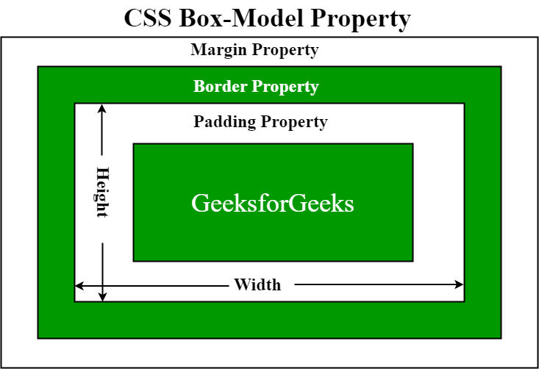

Example:
p {
width: 80px;
height: 70px;
margin: 0;
border: 2px solid black;
padding: 5px;
}
The total width for the element can be calculated as:

Total element width = width + left padding + right padding + left border + right border + left margin + right margin

The <p> element can have a total width of 94px.

Total width = 80px (width) + 10px (left padding + right padding) + 4px (left border + right border) + 0px (left margin + right margin) = 94px.

The total height for the element can be calculated as:

Total element height = height + top padding + bottom padding + top border + bottom border + top margin + bottom margin

The <p> element can have a total height of 84px.

Total height = 70px (height) + 10px (top padding + bottom padding) + 4px (top border + bottom border) + 0px (top margin + bottom margin) = 84px.

3.2.5.1 Height and width

Height and Width in CSS are used to set the height and width of boxes. Its value can be set using length, percentage or auto.

Example:
<!DOCTYPE html>
<html>
<head>
<style>
p {
width:200px;
height:10px;
}
</style>
</head>
<body>
<p>Software Development</p>
<p>Computer Systems and architecture</p><br>
<h2>Height and Width in CSS are used to set the height and width of boxes.</h2>
</body>
</html>
Output:
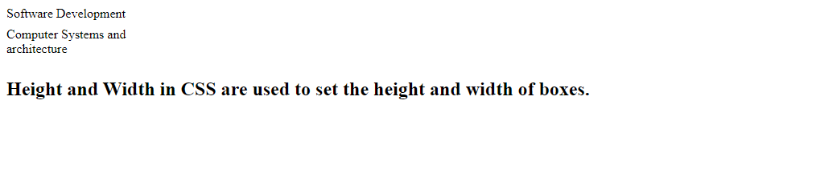

3.2.5.2 Borders

Border property is used to cover the content and any padding. It allows to set the style, color, and width of the border.

3.2.5.3 Border radius
Border radius property sets the rounded borders and provides the rounded corners around an element, tags, or div. It defines the radius of the corners of an element.
It is shorthand for border top-left-radius, border-top-right-radius, border-bottom-right-radius and border-bottom-left-radius. It gives the rounded shape to the corners of the border of an element. We can specify the border for all four corners of the box in a single declaration using the border-radius. The values of this property can be defined in percentage or length units.
If the bottom-left value is omitted, then it will be same as the top-right. If the value of bottom-right is eliminated, then it will be same as the top-left. Similarly, if top-right is eliminated, then it will be the same as top-left.

Let's see what happens when we provide a single value, two values, three values, and four values to this property.
- If we provide a single value (such as border-radius: 30px;) to this property, it will set all corners to the same value.
- When we specify two values (such as border-radius: 20% 10% ;), then the first value will be used for the top-left and bottom-right corners, and the second value will be used for the top-right and bottom-left corners.
- When we use three values (such as border-radius: 10% 30% 20%;) then the first value will be used for the top-left corner, the second value will be applied on top-right, and bottom-left corners and the third value will be applied to the bottom-right corner.
- Similarly, when this property has four values (border-radius: 10% 30% 20% 40%;) then the first value will be the radius of top-left, the second value will be used for the top-right, the third value will be applied on bottom-right, and the fourth value is used for bottom-left.

3.2.5.4 Padding

Padding property is used to create space around the element, inside any defined border.

3.2.5.5 Margin
Margin property is used to create space around the element, around the border area.

3.2.5.6 Visibility

Visibility property is used to specify whether an element is visible or not in a web document but the hidden elements take up space in the web document. Use the display property to remove or display property to both hide and delete an element from the browser.

Syntax:
visibility: visible|hidden|collapse|;

visible: It is the default value. The element is show or visible normally in the web document.

Example:

<!DOCTYPE html>
<html>
<head>
<title>visibility in css</title>
<style>
h1 {
color:green;
visibility: visible;
text-align:center;
}

</style>
</head>
<body>
<h1>Level 3 SOD</h1>
</body>
</html>
Hidden: It hides the element from the page but takes up space in the document.
Example:

<!DOCTYPE html>
<html>
<head>
<title>visibility in css</title>
<style>
h1 {
color:green;
visibility: hidden;
text-align:center;
}
h2{
color:orange;
text-align:center;
}

</style>
</head>
<body>
<h1>Level 3 SOD</h1>
<h2>GS BUMBA TSS</h2>
</body>
</html>

Collapse: It is only used for the table elements. It is used to remove the rows and column from the table but it does not affect the layout of the Table. But their space is available for other content.
Note: This property is not used for other elements except table elements.
Example:

<!DOCTYPE html>
<html>
<head>
<title>
CSS | visibility Property
</title>
<style>
table{
visibility:collapse;
}

</style>
</head>
<body>
<center>
<table border=1>
<tr>
<th>&numero;</th>
<th>Firstname</th>
<th>Lastname</th>
</tr>
</table>
Welcome
</center>
</body>
</html>

3.2.5.7 Auto
You can set the margin property to auto value to horizontally center the element within its container. The element will then take up the specified width, and the remaining space will be split equally between the left and right margins.

Example:

<!DOCTYPE html>
<html>
<head>
<style>
div {
width: 400px;
margin: auto;
border: 1px solid red;
}
</style>
</head>
<body>

<div>
This div will be horizontally centered because it has margin: auto;
</div>

</body>
</html>

3.3 Applying Typography on webpage
3.3.1 Introduction to typography

Typography is the way that text is arranged and presented.

Typography is all about style, proportions, and spacing. Good typography is not only imperative for aesthetic appeal, but it also improves site usability when text legibility and readability concepts are applied.
3.3.2 Use CSS scripts for typography
Typography properties in CSS
Color
Font family

.text1 {
font-family: "Source Sans Pro", "Arial", sans-serif;
}
/* sans-serif font. */
.text2 {
font-family: sans-serif;
}
.text3{
font-family: fantasy;
}
Note: When using multiple values, the list of font families defines the priority in which the browser should choose the font.

Font size
.text1 {
font-size: medium;
}
/* Using pixel values */
.text2 {
font-size: 20px;
}

Font style
.text1 {
font-style: normal;
}
/* slightly slanted text. */
.text2 {
font-style: italic;
}
/* relatively more slanted text */
.text3 {
font-style: oblique;
}

Font weight
.text1 {
font-size: x-large;
font-weight: normal;
}
/* BOLD text. */
.text2 {
font-size: x-large;
font-weight: bold;
}

Letter spacing

.text1 {
font-size: x-large;
letter-spacing: normal;
}
/* using pixel values for spacing. */
.text2 {
font-size: x-large;
letter-spacing: 2px;
}
/* using em values for spacing */
.text3 {
font-size: x-large;
letter-spacing: 0.2em;
}

Word spacing

.text1 {
font-size: x-large;
word-spacing: normal;
}
/* using pixel values for spacing. */
.text2 {
font-size: x-large;
word-spacing: 2px;
}
/* using em values for spacing */
.text3 {
font-size: x-large;
word-spacing: 0.2em;
}

Text align and decoration

.text1 {
font-size: large;
text-align: left;
}
/* using pixel values for spacing. */
.text2 {
font-size: large;
text-align: right;
}
/* using em values for spacing */
.text3 {
font-size: large;
text-align: center;
}
.text4 {
font-size: large;
text-align: justify;
}
.text5 {
font-size: large;
text-decoration: underline;
}
3.3.3 Use HTML tags required for typography
HTML Tags
Tag Usage
h1… h6 Headlines
p Paragraph
strong Bold
em Italic
3.3.4 Embed and position project object in webpage content
3.4 Setting media query rules
3.4.1 Description of media query rules
3.4.1.1 Definition

Media query rules are a key component of responsive web design, allowing developers to apply different styles and layouts to web pages based on the characteristics of the user's device or browser.
Media queries are a critical feature in CSS used to apply styles based on the characteristics of the device or viewport, such as its width, height, orientation, and resolution. This allows for responsive web design, where the layout and appearance of a website can adapt to different screen sizes and device types. Here's a detailed description of the rules and components of media queries:
Basic Structure
A media query consists of a media type and one or more expressions that check for conditions of particular media features.
The basic syntax is as follows:
@media [media type] ([media feature]: [value]) {
/* CSS rules */
}
Media queries can be used to check many things, such as:
- width and height of the viewport
- width and height of the device
- orientation (is the tablet/phone in landscape or portrait mode?)
- resolution
The result of the query is true if the specified media type matches the type of device the document is being displayed on and all expressions in the media query are true. When a media query is true, the corresponding style sheet or style rules are applied, following the normal cascading rules.
3.4.1.2 Identify the device types

Using media queries are a popular technique for delivering a tailored style sheet to desktops, laptops, tablets, and mobile phones (such as iPhone and Android phones).
Media types specify the category of device for which the styles are intended.

- Common media types include:
- all: Suitable for all devices (default).
- screen: Used for computer screens, tablets, smartphones, etc.
- print: Intended for printed documents and documents viewed on a screen in print preview mode.
- speech: Used for screen readers that read the content aloud.

- Media Features
Media features describe specific characteristics of the user agent's environment that can be tested. Some of the most commonly used media features include:
- width: The width of the viewport.
- height: The height of the viewport.
- device-width: The width of the device's screen.
- device-height: The height of the device's screen.
- orientation: The orientation of the device (portrait or landscape).
- aspect-ratio: The ratio of the width to the height of the viewport.
- resolution: The resolution of the device's screen.
- color: The number of bits per color component.
- color-index: The number of entries in the color lookup table of the device.
- monochrome: The number of bits per pixel in a monochrome frame buffer.

- Logical Operators
Logical operators can be used to combine multiple media features or media queries:

- and: Combines multiple media features, all of which must be true.
- or (comma-separated): At least one of the media features must be true.
- not: Negates a media query.
- only: Applies styles only if the entire query matches.
Examples
Basic Example
@media screen and (max-width: 600px) { body { background-color: lightblue; } }
This media query applies a light blue background to the body element only when the viewport width is 600 pixels or less.

Combining Media Features
@media screen and (min-width: 600px) and (max-width: 1200px) { body { background-color: lightgreen; } }

This media query applies a light green background to the body element only when the viewport width is between 600 and 1200 pixels.

Using only and not

@media only screen and (min-width: 600px) {
body {
background-color: lightcoral;
}
}

@media not screen and (max-width: 600px) {
body {
background-color: lightgoldenrodyellow;
}
}

The first query applies a light coral background to the body element only if the viewport is at least 600 pixels wide. The second query applies a light goldenrod yellow background to the body element if the viewport is not 600 pixels or less wide.

Responsive Design Example

* Default styles */
body {
background-color: white;
font-size: 16px;
}

/* Tablets */
@media screen and (min-width: 600px) {
body {
background-color: lightgray;
font-size: 18px;
}
}

/* Desktops */
@media screen and (min-width: 1024px) {
body {
background-color: darkgray;
font-size: 20px;
}
}

In this example, the body element's background color and font size adapt based on the viewport width: white and 16px by default, light gray and 18px for tablets, and dark gray and 20px for desktops.

3.4.2 Use of breakpoint

Breakpoints are specific viewport widths where you want the design of your website to change in response to different device sizes. They are fundamental to responsive design, ensuring that your website adapts smoothly across various screen sizes from mobile phones to desktop monitors.
Key Concepts
- Mobile-First Approach: Start with the base styles for the smallest screen sizes and add media queries to handle larger screens. This ensures that the essential styles are loaded first for faster performance on mobile devices.
- Desktop Breakpoints: Specific points where the layout adapts to larger screens, such as tablets, laptops, and desktops.
Common Breakpoints
Here are some typical breakpoints and their uses:
- 320px: Small mobile devices.
- 480px: Mobile devices.
- 768px: Tablets.
- 1024px: Small desktops and large tablets.
- 1200px: Medium desktops.
- 1440px: Large desktops.
- 1920px: Very large desktops and ultra-wide monitors.
Implementing Breakpoints

Example: Basic Mobile-First Responsive Design

/* Base styles (mobile-first) */
body {
font-size: 16px;
background-color: white;
margin: 0;
padding: 0;
}

.container {
display: flex;
flex-direction: column;
padding: 10px;
}

.item {
margin: 10px 0;
}

/* Small desktops and large tablets */
@media screen and (min-width: 1024px) {
body {
font-size: 18px;
background-color: lightgray;
}

.container {
flex-direction: row;
flex-wrap: wrap;
}

.item {
flex: 1 1 48%;
margin: 10px;
}
}

/* Medium desktops */
@media screen and (min-width: 1200px) {
body {
font-size: 20px;
background-color: lightblue;
}

.item {
flex: 1 1 32%;
}
}

/* Large desktops */
@media screen and (min-width: 1440px) {
body {
font-size: 22px;
background-color: lightgreen;
}

.item {
flex: 1 1 24%;
}
}

/* Very large desktops and ultra-wide monitors */
@media screen and (min-width: 1920px) {
body {
font-size: 24px;
background-color: lightcoral;
}

.item {
flex: 1 1 19%;
}
}

Explanation
- Base Styles: These are the default styles applied to all devices. Starting with a mobile-first approach ensures the essential styles load first.
- Media Queries: As the screen width increases, media queries apply additional styles or modify existing ones to enhance the layout for larger screens.

3.4.2.1 For Desktop

Common Desktop Breakpoints

While there is no one-size-fits-all approach, certain breakpoints are commonly used for desktop layouts. These breakpoints are based on typical screen widths and are intended to cover a broad range of devices:
- 1024px: This is often used as a breakpoint for the smallest desktop screens, such as small laptops and large tablets in landscape mode.
- 1200px: This is a common breakpoint for medium-sized desktop screens, covering most standard laptops and desktops.
- 1440px: This breakpoint is for larger desktop screens, such as high-resolution laptops and desktop monitors.
- 1920px: This is used for very large desktop screens and ultra-wide monitors.
Implementing Breakpoints for Desktop
Here are examples of how to use breakpoints in your CSS for desktop layouts:
Example:

/* Base styles for mobile-first approach */
body {
font-size: 16px;
background-color: white;
}

/* Small desktops and tablets in landscape */
@media screen and (min-width: 1024px) {
body {
font-size: 18px;
background-color: lightgray;
}
}

/* Medium desktops */
@media screen and (min-width: 1200px) {
body {
font-size: 20px;
background-color: lightblue;
}
}

/* Large desktops */
@media screen and (min-width: 1440px) {
body {
font-size: 22px;
background-color: lightgreen;
}
}

/* Very large desktops and ultra-wide monitors */
@media screen and (min-width: 1920px) {
body {
font-size: 24px;
background-color: lightcoral;
}
}

3.4.2.2 For Tablet

When designing for tablets, breakpoints typically fall between the smaller mobile screen sizes and the larger desktop sizes. The most common breakpoints for tablets are around 768px to 1024px. These breakpoints ensure that the design adjusts to fit both portrait and landscape orientations of tablets.
Common Tablet Breakpoints
- 768px: This breakpoint is often used for smaller tablets and the portrait orientation of larger tablets.
- 1024px: This breakpoint is commonly used for larger tablets and the landscape orientation of most tablets.
Implementing Tablet Breakpoints
Here are examples of how to use these breakpoints in your CSS:
Example: Basic Mobile-First Responsive Design for Tablets

/* Base styles (mobile-first) */
body {
font-size: 16px;
background-color: white;
margin: 0;
padding: 0;
}

.container {
display: flex;
flex-direction: column;
padding: 10px;
}

.item {
margin: 10px 0;
}

/* Tablets in portrait and small tablets in landscape */
@media screen and (min-width: 768px) {
body {
font-size: 18px;
background-color: lightgray;
}

.container {
flex-direction: row;
flex-wrap: wrap;
}

.item {
flex: 1 1 48%;
margin: 10px;
}
}

/* Tablets in landscape */
@media screen and (min-width: 1024px) {
body {
font-size: 20px;
background-color: lightblue;
}

.item {
flex: 1 1 30%;
}
}

Explanation
- Base Styles: These are the default styles applied to all devices, starting with a mobile-first approach.
- Tablet Portrait (768px): When the viewport width reaches 768px, adjustments are made to enhance the layout for tablet screens in portrait orientation. The container switches to a row layout with wrapped items.
- Tablet Landscape (1024px): When the viewport width reaches 1024px, additional adjustments are made for tablets in landscape orientation. The font size increases, and the items are arranged to take up 30% of the container width.

Responsive Layout Example for Tablets

Here's an example focusing on layout adjustments, like changing from a single-column layout on mobile to a multi-column layout on tablets:

/* Base styles (mobile-first) */
.container {
display: flex;
flex-direction: column;
padding: 10px;
}

.item {
margin: 10px 0;
}

/* Tablets in portrait and small tablets in landscape */
@media screen and (min-width: 768px) {
.container {
flex-direction: row;
flex-wrap: wrap;
}

.item {
flex: 1 1 48%;
margin: 10px;
}
}

/* Tablets in landscape */
@media screen and (min-width: 1024px) {
.item {
flex: 1 1 30%;
}
}

3.4.2.3 For Smartphone

When designing for smartphones, breakpoints are essential for ensuring that your web design adapts effectively to different screen sizes and orientations. Smartphones have a wide range of screen sizes, so it's important to define breakpoints that cover the most common sizes to provide an optimal user experience.
Common Smartphone Breakpoints
Here are some widely used breakpoints for smartphones:

- 320px: For small smartphones.
- 375px: For average-sized smartphones (e.g., iPhone SE, iPhone 8).
- 414px: For larger smartphones (e.g., iPhone 11 Pro Max, Google Pixel 4 XL).
- 480px: For the largest smartphones and phablets.
Implementing Smartphone Breakpoints
Here's how you can implement these breakpoints in your CSS using a mobile-first approach:
Basic Mobile-First Responsive Design for Smartphones

body {
font-size: 14px;
background-color: white;
margin: 0;
padding: 0;
}

.container {
display: flex;
flex-direction: column;
padding: 10px;
}

.item {
margin: 10px 0;
}

/* Small smartphones */
@media screen and (min-width: 320px) {
body {
font-size: 15px;
}

.item {
margin: 8px 0;
}
}

/* Average-sized smartphones */
@media screen and (min-width: 375px) {
body {
font-size: 16px;
}

.item {
margin: 10px 0;
}
}

/* Larger smartphones */
@media screen and (min-width: 414px) {
body {
font-size: 17px;
}

.item {
margin: 12px 0;
}
}

/* Largest smartphones and phablets */
@media screen and (min-width: 480px) {
body {
font-size: 18px;
}

.

3.4.3 Media orientation
The orientation CSS media feature can be used to test the orientation of the viewport. The orientation feature is specified as a keyword value chosen from portrait and landscape.
3.4.3.1 Portrait
The viewport is in a portrait orientation if the height is greater than or equal to the width.
3.4.3.2 Landscape
The viewport is in a landscape orientation if the width is greater than the height.

3.4.4 Hide elements with media queries

To hide an element in a responsive layout, we need to use the CSS display property set to its "none" value along with the @media rule.
The content of the second <p> element having a "hidden-mobile" class will be hidden on devices smaller than 767px.

3.4.5 Variable Font Size

